ADDENDUM #1
ATCAA Food Bank Backup Generator Project RFP | August 12, 2020
The following information is provided to the potential Proposers for the above named RFP and shall become a part thereof pursuant to Section X, Paragraph 5 (Addenda) of the RFP. No consideration will be allowed due to any potential proposer not being aware of or familiar with this addendum.
The proposer must acknowledge receipt of this addendum on its Proposal Form/Bid Form in order for its Proposal to be deemed acceptable. This addendum shall form part of the RFP Solicitation and is to be read, interpreted, and coordinated with all other parts. The following revisions supersede the information contained in the original instructions and specifications issued for the above named project. This Addendum #1 contains 2 pages in total.
______________________________________________________________________________
This purpose of this Addendum is to make the following change:
  - Change the location of the propane tank.
______________________________________________________________________________
ADDENDUM 1.1
Addendum 1.1 modified Exhibit C (Diagrams & Specifications - Design/Layout, as well as Contractor Narrative/Drawing) of the RFP Solicitation to indicate the location of the propane tank in regards to the location of the generator set. The original location of the propane tank was intended to be directly adjacent to the generator set.
The location of the propane tank has now been changed. It will still be placed by others.
The existing underground gas line has been deemed sufficient to meet the minimum fuel line requirements of the generator set. The new location will be on the property line, against the fence, where the high pressure gas line begins. See drawing below (Basic Layout Design). This physical location will also be shown during the mandatory walk-thru.

BASIC LAYOUT DESIGN

=Underground
Gas Line & Stubs

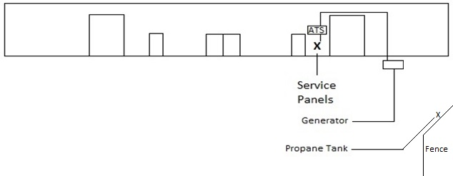
_____________________________________________________________________________________
REMINDER: Acknowledge the receipt of Addendum #1 on the Proposal Form/Bid Form Exhibit B.
END OF ADDENDUM

